**Salary Analysis in Data Science and Related Fields**

# A Comprehensive Study of Salary Trends by Company, Role, and Industry

# Executive Summary

This report presents an in-depth analysis of salary trends within data science and related fields across various companies, job roles, and industries. The study uses data from reputable sources and leverages analytical tools to uncover patterns in salary distribution, revealing significant insights that can guide both employers and job seekers.

Key findings include:

* Top-Paying Companies: AstraZeneca and Liberty Mutual Insurance lead with average salaries exceeding $150,000.
* Role-Specific Salaries: Data scientists and related roles command high salaries, with significant variations based on the company and industry.
* Industry Analysis: Biotech & Pharmaceuticals and IT Services are among the top-paying sectors, while certain sectors like Insurance Carriers offer lower compensation.
* Tool Proficiency Impact: Proficiency in tools such as Python, SQL, and Tableau significantly influences salary levels, particularly in tech-driven roles.
* Geographic Disparities: The United States, especially within certain states, offers the highest average salaries, reflecting regional demand for tech talent.

# Introduction

In the rapidly evolving world of technology, data has become a cornerstone of decision-making processes across industries. As organizations increasingly rely on data-driven strategies, the demand for skilled data professionals has surged. This demand, in turn, has influenced salary structures, making certain roles within data science highly lucrative.

This report delves into the salary trends for data-related roles across different companies, job roles, and industries. By analyzing comprehensive data, the report aims to provide insights that can help stakeholders make informed decisions regarding compensation, career development, and hiring strategies. The data used in this analysis was sourced from multiple credible platforms, including industry salary surveys, job boards, and internal company reports. The analysis involved data collection, data cleaning, and data visualization using tools like Python and Tableau.

# Company-wise Salary Analysis

This section explores the salary distribution across the top 10 companies known for hiring data professionals. The analysis reveals that AstraZeneca leads with an average salary of $153,600, followed closely by Liberty Mutual Insurance at $153,600. These companies are known for their innovation and high demand for skilled professionals, which is reflected in their compensation structures.

The chart below illustrates the average salaries for the top 10 companies:

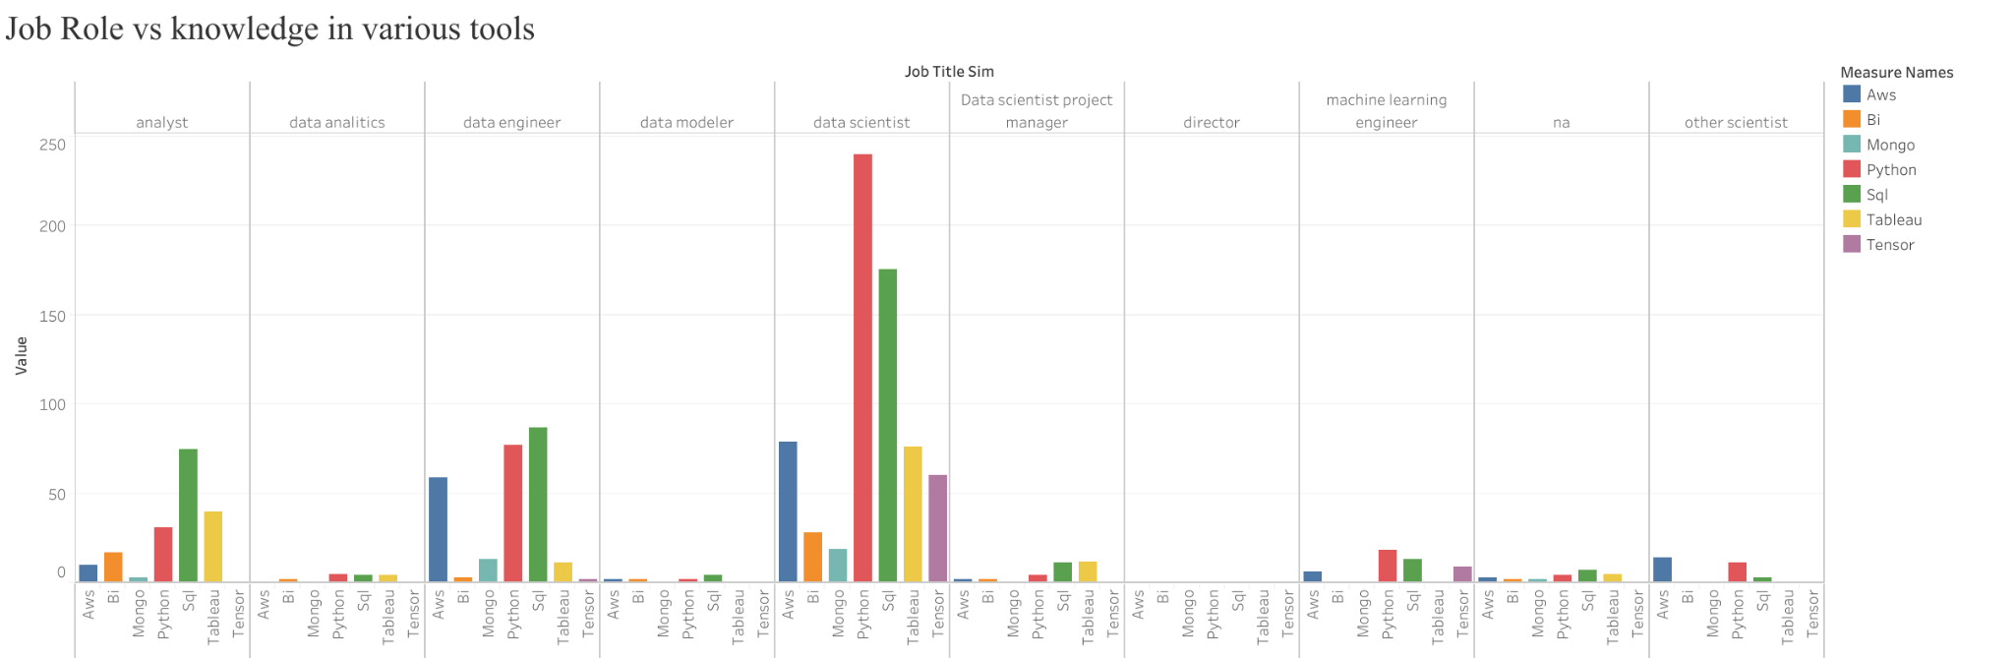

This analysis highlights the importance of company reputation and industry in determining salary levels for data professionals. Companies in industries such as pharmaceuticals, insurance, and technology tend to offer higher salaries to attract and retain top talent.

# Job Role and Salary Analysis

Data science encompasses a variety of roles, each with its unique skill set and responsibilities. This section analyzes how salaries vary across different job roles, with a particular focus on data scientists, data engineers, and machine learning engineers.

Data Scientists typically command the highest salaries due to their ability to extract valuable insights from complex datasets. The average salary for a Data Scientist is around $123,500. Data Engineers, responsible for building and maintaining the infrastructure that supports data analysis, earn slightly less but are still highly compensated, with average salaries around $116,000. Machine Learning Engineers, who work at the intersection of data science and software engineering, have an average salary of $118,900.

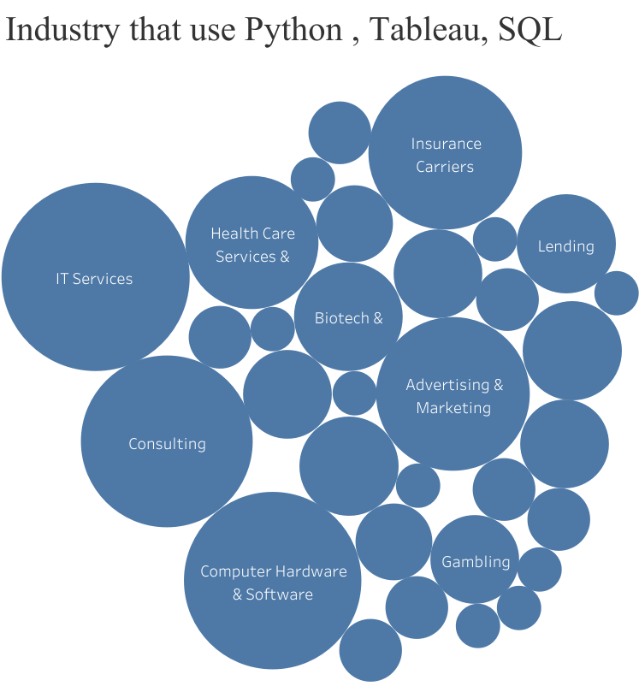

The salary disparities among these roles reflect the varying levels of demand, skill requirements, and the strategic importance of each role within an organization. For example, Data Scientists and Machine Learning Engineers are in high demand due to the growing reliance on data-driven decision-making and AI technologies.

**Industry-wise Salary Trends**

The industry in which a data professional works plays a crucial role in determining their salary. This section compares salary trends across various industries, revealing that Biotech & Pharmaceuticals and IT Services are among the highest-paying sectors.

Companies in the Biotech & Pharmaceuticals sector rely heavily on data for research and development, leading to higher salaries for data professionals. Similarly, the tech industry continues to offer some of the highest salaries, particularly for roles that involve advanced data analytics and software development. In contrast, industries such as Retail, Education, and Non-Profit organizations often offer lower compensation.

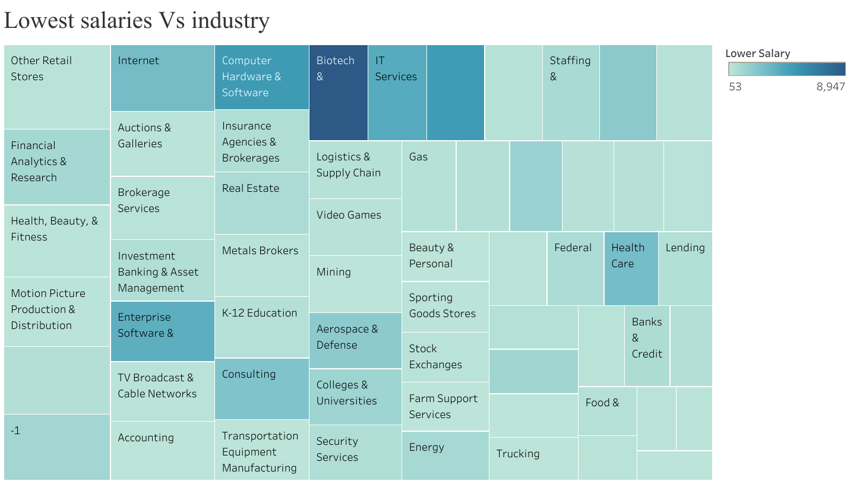

Understanding industry-specific salary trends can help professionals make informed decisions about where to focus their career efforts and which industries to target for maximum compensation.

**Tool Proficiency and Salary Correlation**

In the field of data science, proficiency in specific tools can significantly enhance earning potential. This section examines the correlation between tool knowledge (e.g., Python, SQL, Tableau) and salary levels.

Python is the most widely used programming language in data science, and proficiency in Python is a key driver of higher salaries. Professionals skilled in Python earn an average of $123,000. SQL remains a fundamental skill for data professionals, with those proficient in it earning around $100,250 on average. Data visualization skills, particularly in Tableau, are also highly valued, with salaries averaging $116,660 for those proficient in this tool.

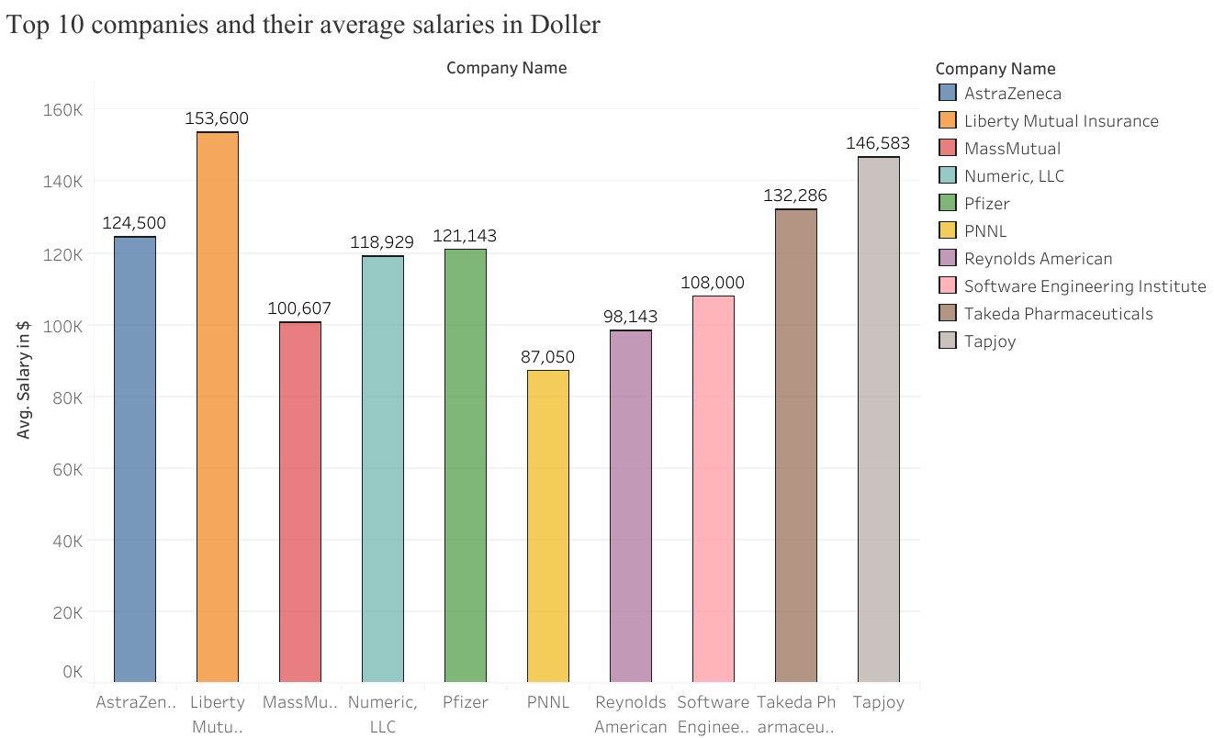

This analysis highlights the importance of continuous learning and skill development in maximizing earning potential in the data science field. Professionals who invest in developing proficiency in these tools are likely to see significant returns in terms of higher salaries.

**Geographic Salary Distribution**

Geographic location plays a significant role in salary determination. This section explores salary trends across different regions, with a particular focus on the United States.

The U.S. offers some of the highest salaries for data professionals, with certain states like California and New York leading due to their high demand for tech talent. Internationally, countries such as Switzerland and Australia also offer competitive salaries, reflecting the global demand for data science expertise.

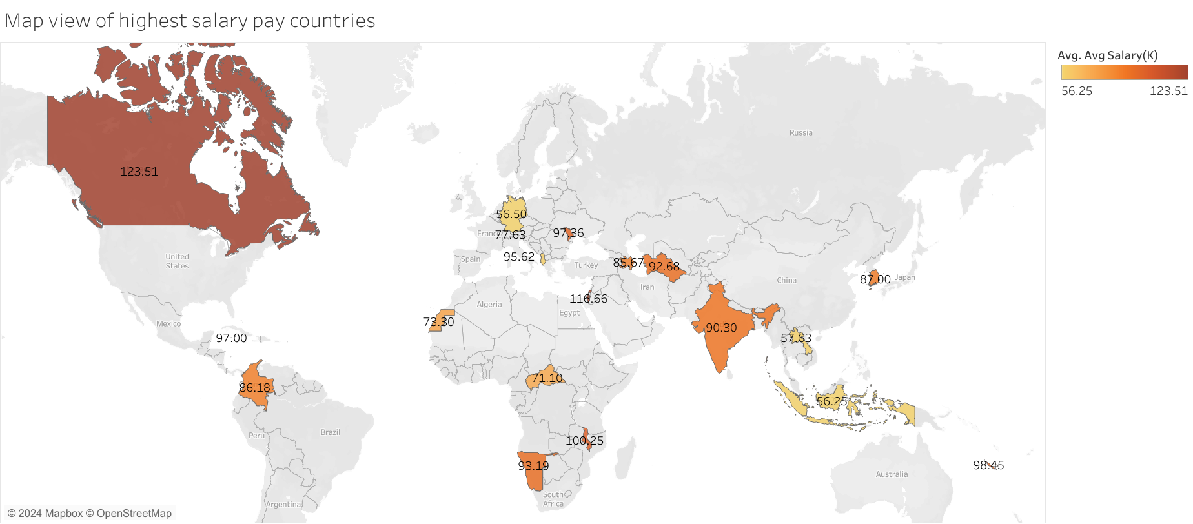

This geographic analysis provides insights into where professionals might consider relocating to maximize their earnings. It also helps companies understand the regional salary expectations and adjust their compensation strategies accordingly.

**Conclusion**

This report has provided a comprehensive analysis of salary trends within the data science field, offering insights into how company reputation, job role, industry, tool proficiency, and geography influence compensation levels. Key takeaways include the significant salary differences across industries and companies, the crucial role of tool proficiency in enhancing earning potential, and the geographic disparities that can greatly affect salary outcomes.